Session 1
Q1.
Install Node.js and use npx create-react-app to set up a new React project called InstaCloneStarter on your computer.
Ans.

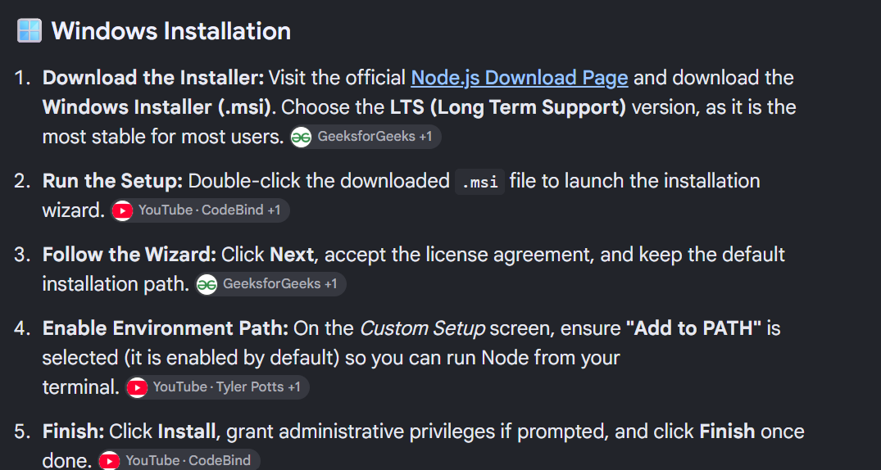

npx-create-react-app instaclonerstarter
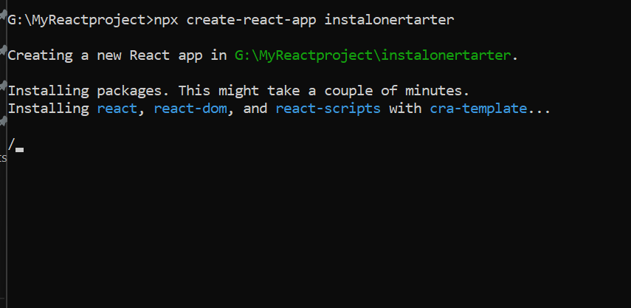

2.
Open App.js in your InstaCloneStarter project and change the default text to display 'Welcome to My React Zomato App' inside an <h1> tag.
Ans.

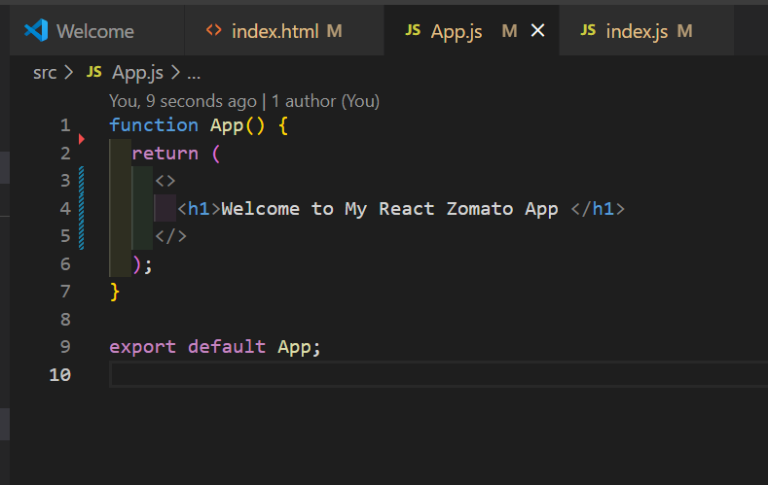
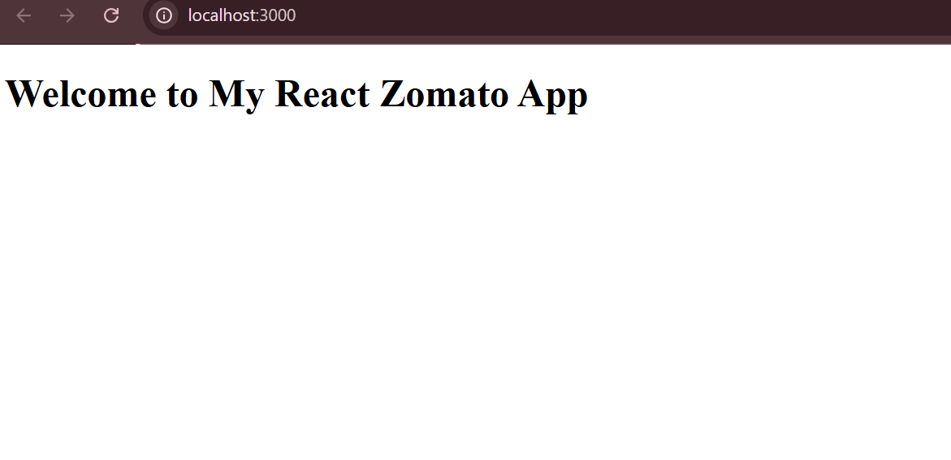
3.
Create a new functional component called TrendingSong.js that returns an <h2> element with the text 'Trending on Spotify: Calm Down'. Import and use this component inside App.js so it shows below your main heading.
Ans.
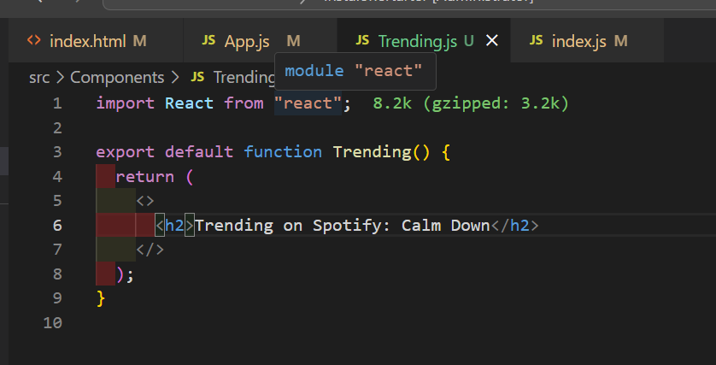
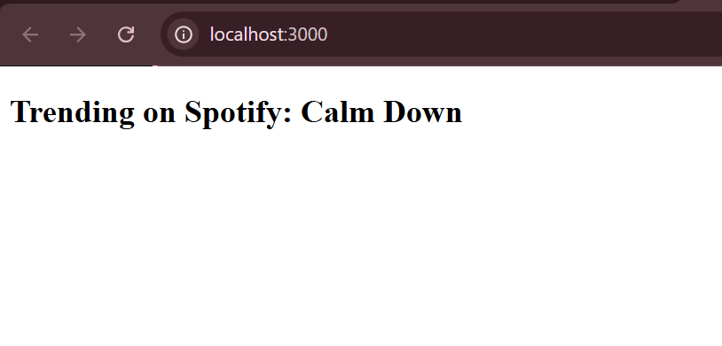
4.
Explain in your own words (3-4 lines) how React's Virtual DOM makes updating the UI faster compared to traditional DOM manipulation.
Ans.
• React keeps a lightweight copy of the UI in memory called the Virtual DOM.
• When the UI changes, React compares the new copy with the previous one.
• It updates only the changed parts of the real DOM, making updates more efficient.

